Project Design Phase
Solution Architecture
Date | 24-10-2026
Team ID | [Individual Project Submission]
Project Name | IMovies — Movie Ticket Booking Made Simple
Maximum Marks | 4 Marks

Solution Architecture:
The solution architecture for IMovies ensures a robust, user-friendly, concurrency-safe, and scalable movie ticket booking platform. The architecture focuses on responsive design, secure session management, real-time catalog discovery, interactive visual seat mapping, and atomic database reservation logic to guarantee smooth workflows and high customer satisfaction.
- Seamless Movie Discovery & Seat Selection: Single Page Application (SPA) with dark cinema theme, live search, and dynamic seat grid.
- End-to-End Booking Lifecycle Management: Complete booking funnel from showtime exploration to instant confirmation receipt and booking history.
- Scalable User Authentication & Security: Stateless JSON Web Token (JWT) architecture with bcrypt password hashing (10 salt rounds).
- Atomic Concurrency & Seat Locking Safety: Atomic MongoDB update operations ($addToSet / $nin) guaranteeing zero double-bookings.
- Reliable User Feedback & Error Handling: Immediate visual feedback via toast alerts, modal trailers, and active status tracking.
Example - Solution Architecture Diagram:
Figure 4.1 illustrates the 3-tier MERN architecture, detailing the interaction between the React client, Express REST API, authentication middleware, and MongoDB data collections:
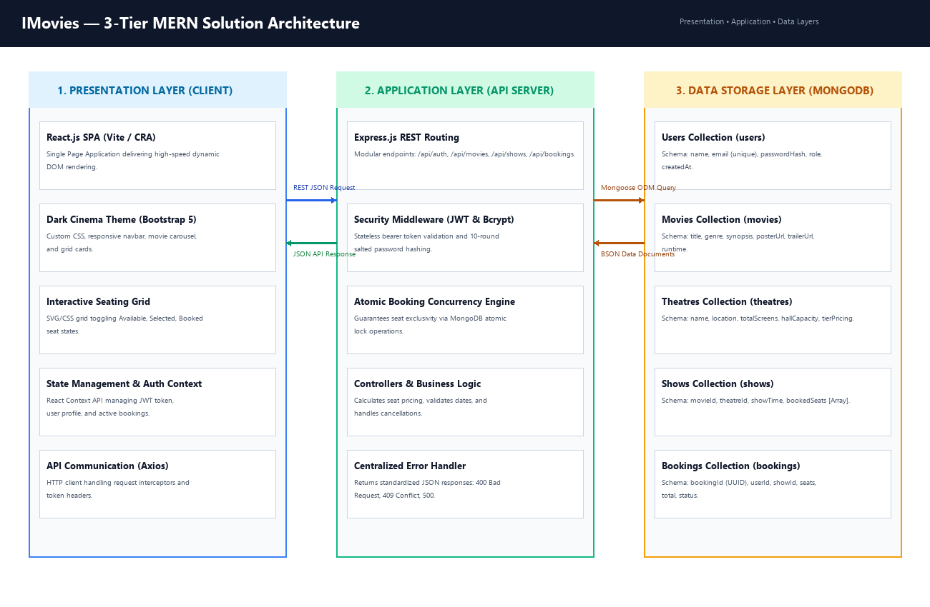
Figure 4.1: IMovies 3-Tier MERN Architecture Diagram
Seat Booking Concurrency & Race Condition Handling:
In movie ticketing applications, simultaneous seat selection by multiple users represents a critical architectural risk. A client-side availability check alone is insufficient to guarantee that a seat cannot be double-booked.
IMovies resolves this challenge through server-side atomic locking. When a booking request arrives, the Express controller invokes MongoDB's findOneAndUpdate with an atomic query constraint checking that no requested seat exists in the bookedSeats array. If two users select the same seat within milliseconds, the database commits the first write atomically, while the second write matches zero records and is immediately rejected with HTTP 409 Conflict.
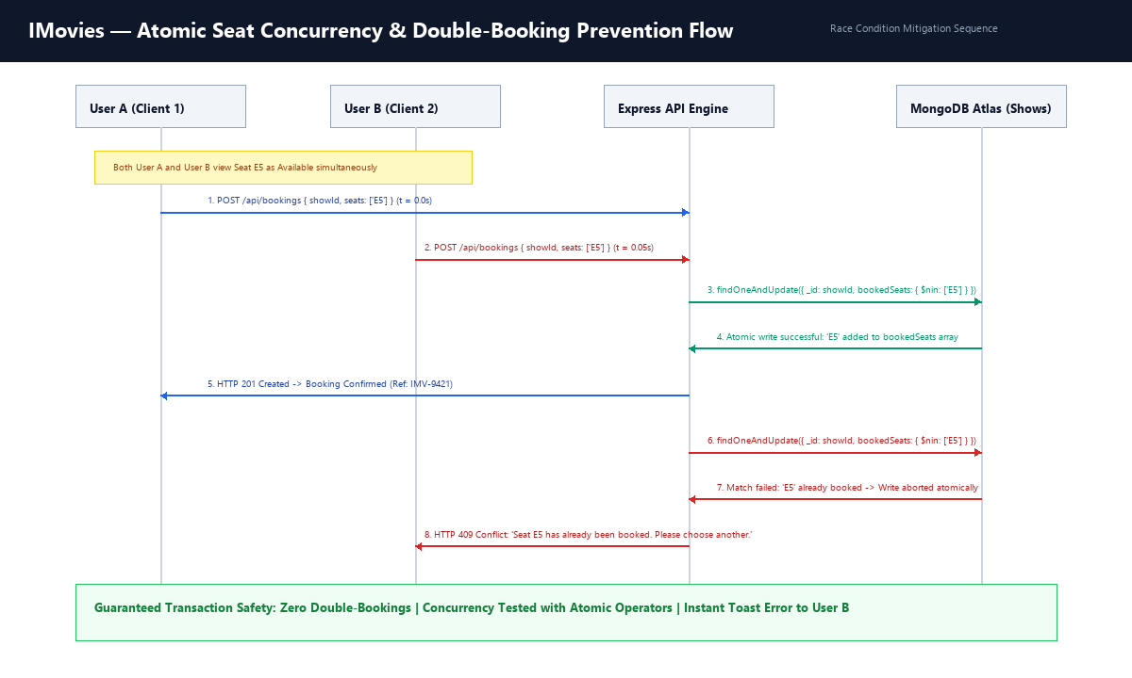
Figure 4.2: Atomic Concurrency & Race Condition Resolution Sequence

